Queue System Design for File transfer:

Primary requirements:

1. Queue should allow transfer of files from one system to another.
2. Client logics are completely decoupled.
3. The type of files being allowed are customizable.

Database design:

Queue server module DB design

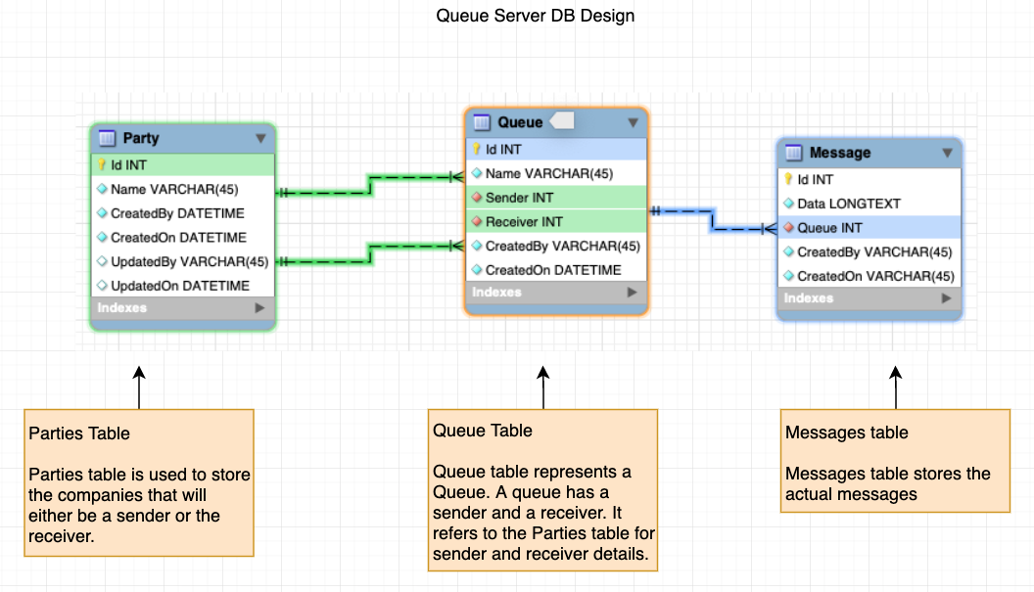

Queue Sender client DB design

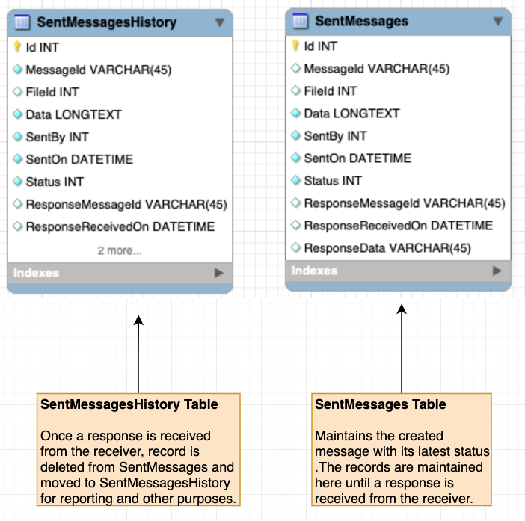

Queue Receiver DB design

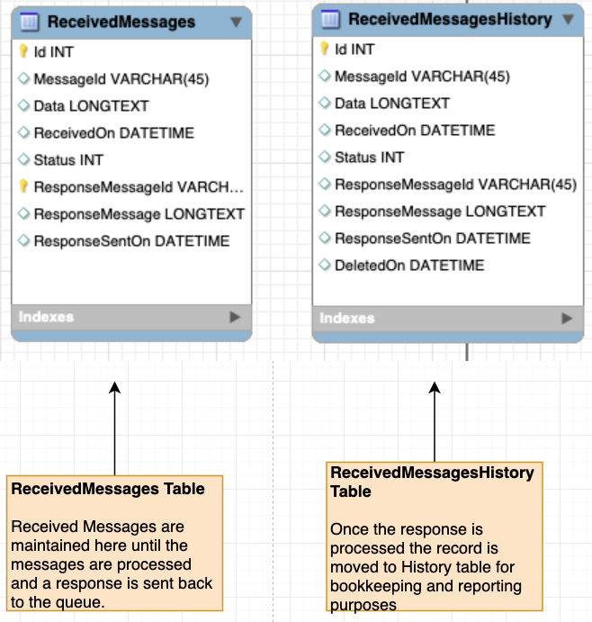

FileServer DB design:

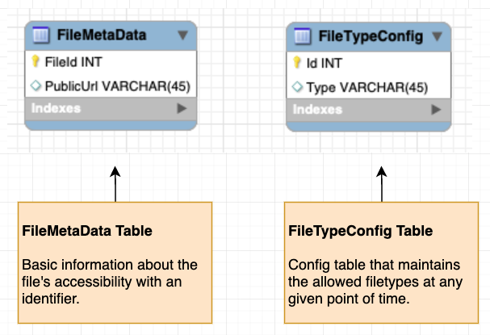

Qeueue System Class diagram:

Please find the file **Queue System Class Diagram.svg** in the source code repo.

High Level Architecture:

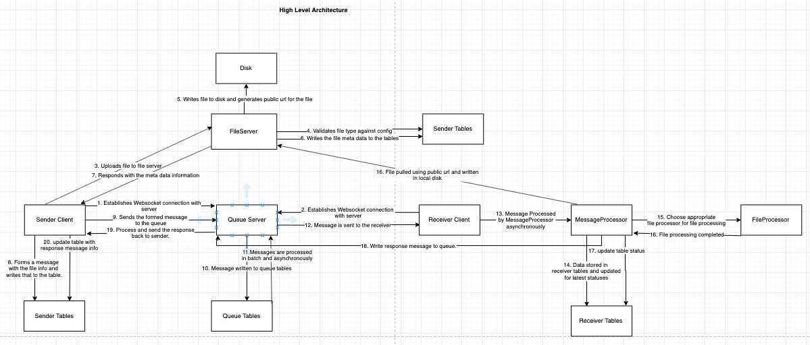

Also, look at the file HighLevelArchitechture.png in the source code repo for better clarity.